Project Report

|  |  |
| --- | --- |
| Product Name | Advanced Certificate in Web Development |
| Qualification Name (NICF) | ITSF - Advanced Certificate in Information Technology (Application Development) |
| Product Name | Front End Web Development |
| Module Name (NICF) | ITSF - Front End Web Development |

|  |  |  |  |
| --- | --- | --- | --- |
| Student name | | Assessor name | |
| Chathuhi Dilhari | | Mr.Bhagya Battage | |
| Date issued | Completion date | | Submitted on |
| 31.03.2022 | 07.05.2022 | | 11.05.2022 |
|  | |  | |
| Project title | Development of website for a Training Organization | | |

|  |
| --- |
| Learner declaration |
| I certify that the work submitted for this assignment is my own and research sources are fully acknowledged.  Student signature: Chathushi Date:10/05/2022 |

Project Content

1. Project Background 3

1. Task 1 7

01) Project Scope 7

02) Project Out of Scope 7

03) Functional Requirements 7

04) Non Functional Requirements 9

05) Technical Requirements 9

2. Task 5 10

01) Effectiveness of the designed Lead Generation Administration System. 10

02) effectiveness of the User interface according to 2 metrics 12

3. Task 7 13

01) USER GUIDE FOR LEAD GENERATION FORM 13

02) USER GUIDE FOR LEAD ADMINISTRATIVE SYSTEM 17

Project Background

* Project Definition

The websites come in a nearly endless variety, including educational sites, news sites, social media sites and so on. According to above website this is a educational site named ABC Learning Centre. The ABC Learning centre was formed in response to learning on person and increasing virtual rates.

* Project Objective
* Business Goals
* Increase new courses followers’ reviews by 30% year over year
* Increase course fee by 4% over the next four months
* Increase student’s enrollment by 60% within six months
* Develop and launch three new courses.
* Open new centers locations throughout the Sri Lanka
* User Goals
* Ensure that learners can obtain copies of their own (and only their) records on a timely manner.
* To learn more about the recognition of certification.
* To check for Institute’s contact details.
* To check who are the mentors teaching and their qualifications for each other.
* To getting clearly understand of courses structures and lectures.
* Proposed Solution
* Provide 24/7 chat box, Hotline
* Design and Implement website
* Develop incentive pay plan
* Development Tool
* Visual Studio Code – To coding the website

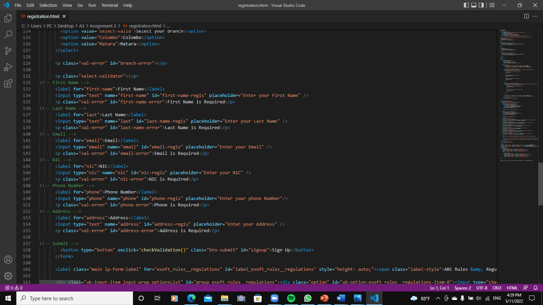

Figure 1: Screenshot of Visual Studio Code

* 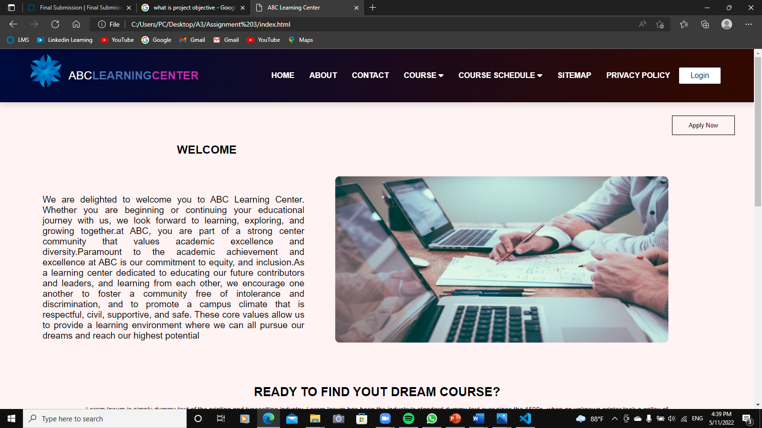Microsoft Edge – To view the website

Figure 2: Screenshots of MS Edge

* 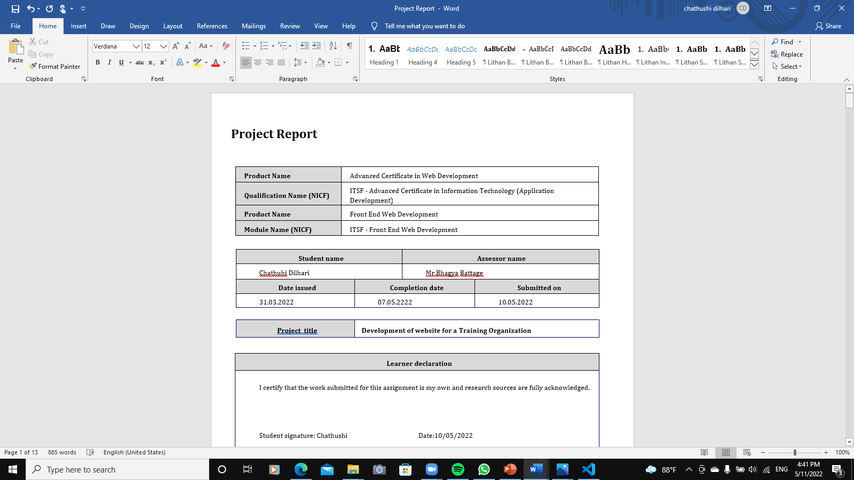MS word – To make Project Report

Figure 3:Screenshot of MS Word

* 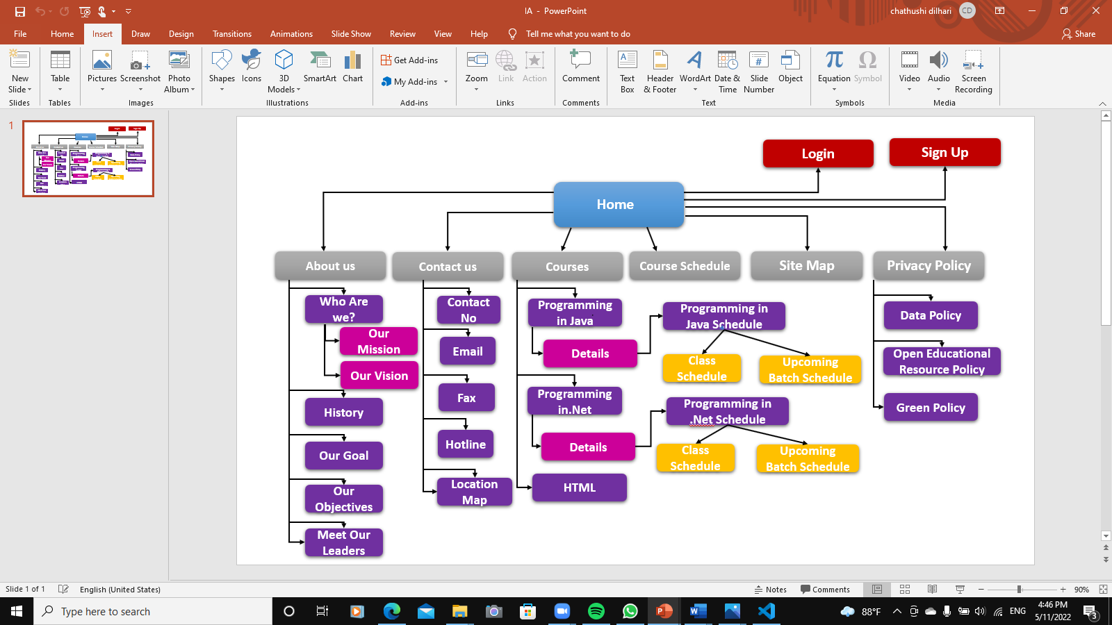MS power point – To make Information Architecture, Project Presentation

Figure 4:Screenshot of power point (IA)

* 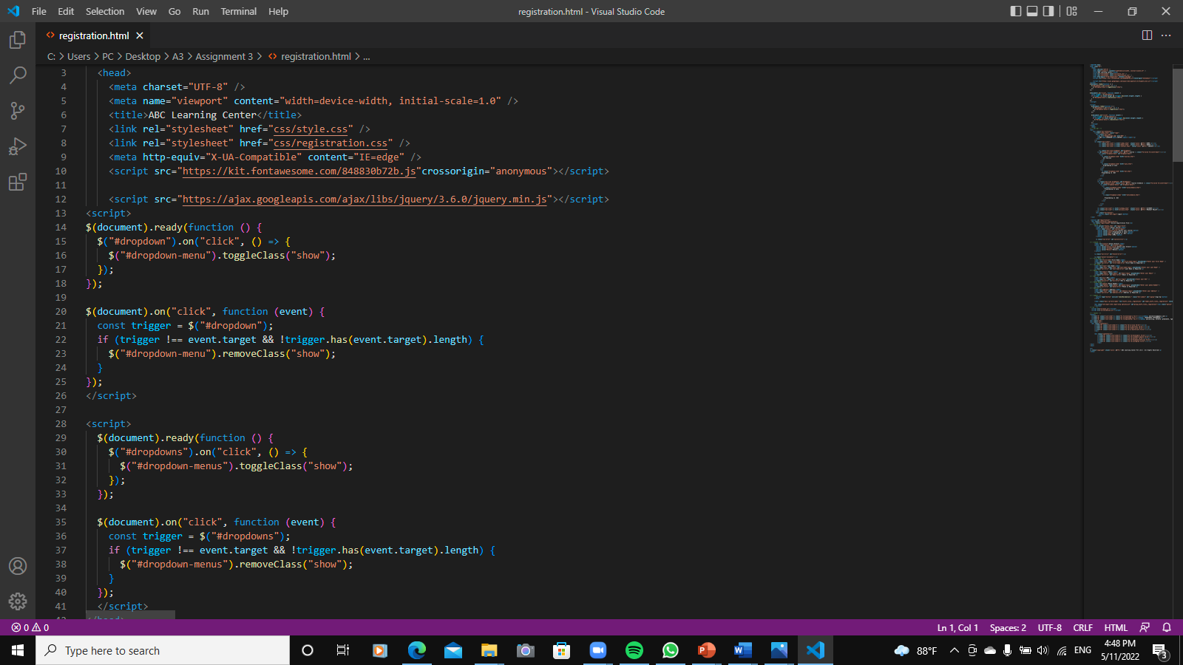JQUERY- To develop Menus

Figure 5: Screenshot of jQuery coding

# Task 1

1. Project Scope

* Lead Generation Form
* Lead Administration

1. Project Out of Scope

* Back up Site
* Responsive page for administration
* Integration with database

1. Functional Requirements
   * Common Content
     + **Header** – A website header sits at the top of each page a few very important purposes. Header is a narrow strip in the top parts of the website that contained a logo, site name.

* + - **Footer** – Section of content at the very bottom of a website. According to my website it contains email, address, contact numbers, social media links and payment methods
* + - **Navigation** – It contain navigations such as home, about, contact and etc.
* + **Home Page** – It is a default page of my website. It contains highlights, details etc.
  + **About Us Page** – This page provides information (History, Mission, Vision, goals) of ABC Learning center
  + **Courses List Page** – Courses offered from ABC learning center
  + Course Details Page
    - **Programming in Java details** – This contains course programming in Java details, Entry requirements, commencements etc.
    - **Programming in .Net details** - This contains course programming in .NET details, Entry requirements, commencements etc.
  + Course Schedule Page
    - **Programming in Java schedule** – This page contains course programming in Java class schedules, upcoming batch schedules.
    - **Programming in .Net schedule** - This page contains course programming in .NET class schedules, upcoming batch schedules
  + **Contact Us Page** – This page provides visitors with information on how they can get in touch with ABC learning Center.
  + Lead Registration Form Page
    - **Select course** – visitors can select courses which they want
    - **Select branch** – Visitors can select branch that they want to study
    - First Name
    - Last Name
    - Email
    - NIC
    - Phone Number
    - Address
* + **Lead Registration Thank You Page** – After successful registration visitor arrives this page.
  + Lead Administration Page
    - **Edit** – To EDIT leads information
    - **Delete** – To DELETE Leads
    - **Add** - To EDIT and replace leads or to ADD new leads
  + **Sitemap Page** – All Pages Links. Visitor can easily go to the pages that the want.
  + **Privacy Policy Page** – ABC Learning center privacy policies such as green policy etc.

1. Non Functional Requirements

* Performance

ABC can reduce overall load time and load quickly, add video pop-ups to get more interest about courses

* 24/7 chat box, hotline
* Back up website data hourly
* Update site Monthly

1. Technical Requirements

* Software
* Programming Languages such as HTML, CSS, JavaScript etc.
* Applications – Chromes, Microsoft Edge, Balsamiq Wireframes
* MS Offices – MS Word, MS Power point
* Hardware
* Windows 10, Windows 11, IOS

# Task 5

1. Effectiveness of the designed Lead Generation Administration System.

To the effectiveness of the designed lead generation Administration system the very first thing is, obstacles in providing the right source courses from past experience were no capability to verify any visited users if there any duplicated user or not and not able to manage user information so that company can promote their products. **Administrative** systems refer to systems and processes for filing and record keeping, office correspondence, visitor and phone call management, internal communication, financial management and other administrative duties. Those systems should be understood and followed by all staff members to ensure a smooth functioning of your organization.

For the effectiveness of lead generation form we can add validation to all details of the form. Such as First Name and Last Name cannot be blank, NIC no must have 12 digits, phone no must include 10 numbers, email must include ‘@,.’ After add validations visitors cannot sign up the lead generation form without filling all the details.

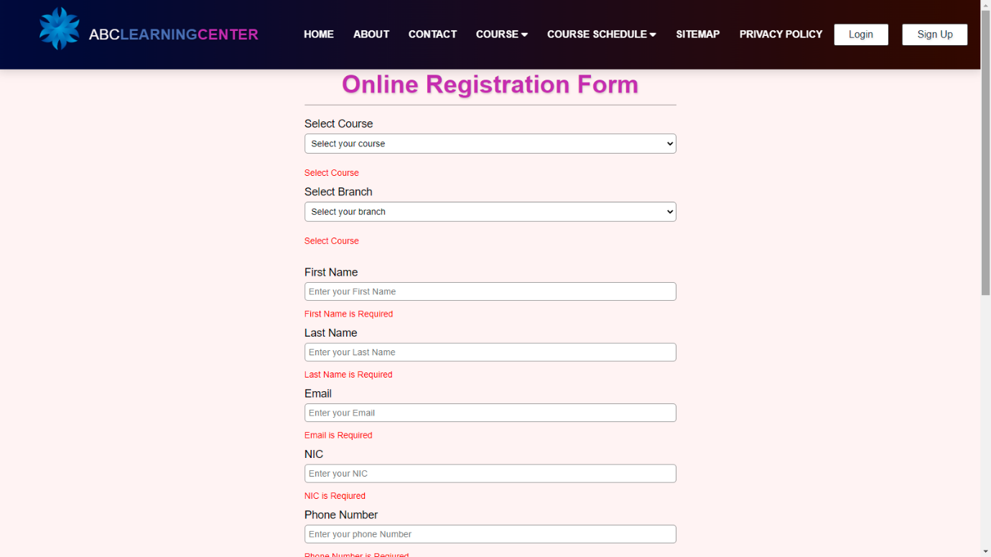

Figure 6: Validations of Lead Generation Form

After Sign Up the details goes to the Lead administration page and data stored in local storage. Only admins can see and handle the administration page. They (Admins) can *edit* leads, *delete* leads or *add* details. This is the one thing that do for the effectiveness of lead generation administration system.

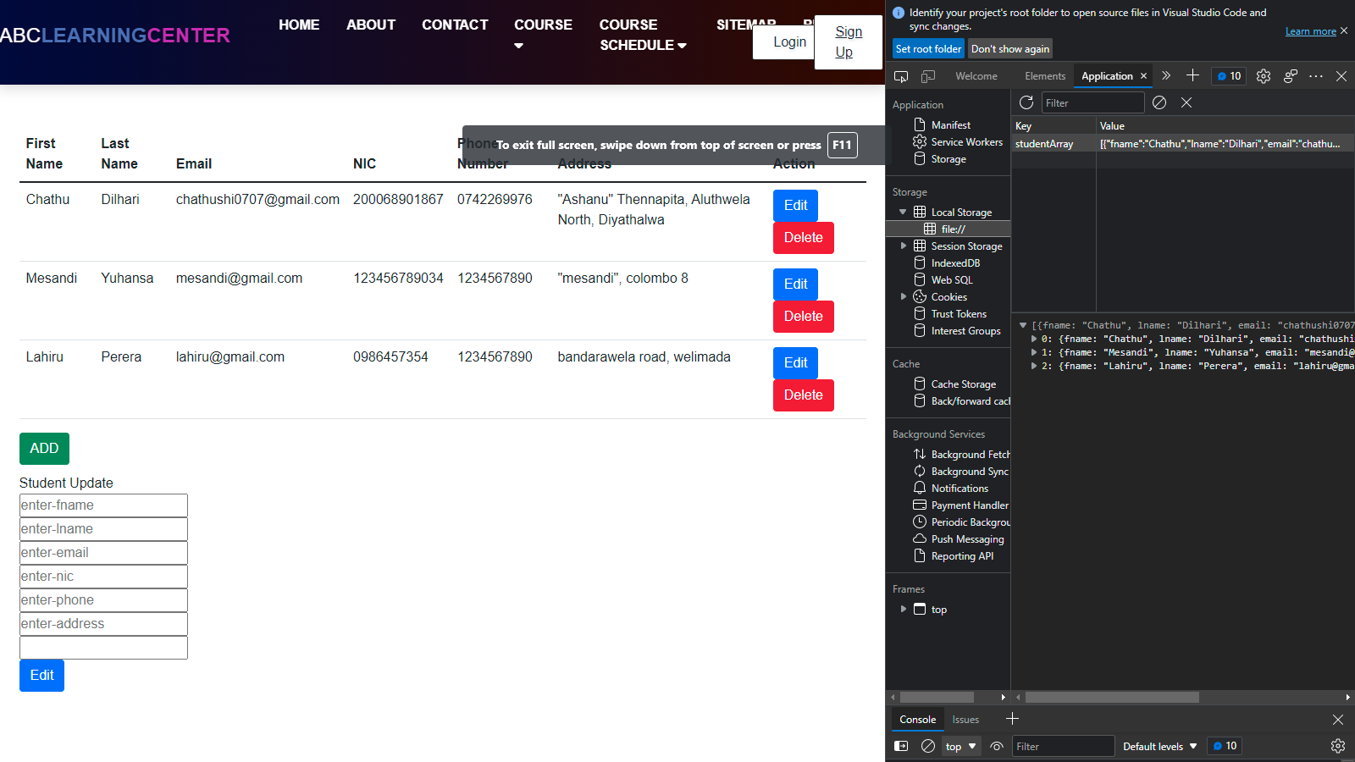

Figure 7: Screenshot of Lead Administration

1. effectiveness of the User interface according to 2 metrics

* Understandability
* Look and feel and well-designed user interface attracts user and gives them knowledge of what to do next. This mean that the content should be understandable both by the users themselves and by assistive technologies such as screen readers.
* Reliability
* The error messages of validations, educates and motivates user to enter correct credentials at a minimum attempt. When we determine the site’s look, If a site looks poorly designed and amateurish chances is a bad for the site admins. It will break the visitors trust. For the effectiveness web designers have to design professional website using more highlights, proofs, reviews etc.

# Task 7

01) USER GUIDE FOR LEAD GENERATION FORM

Step 1 - At the Home page click on Sign Up button

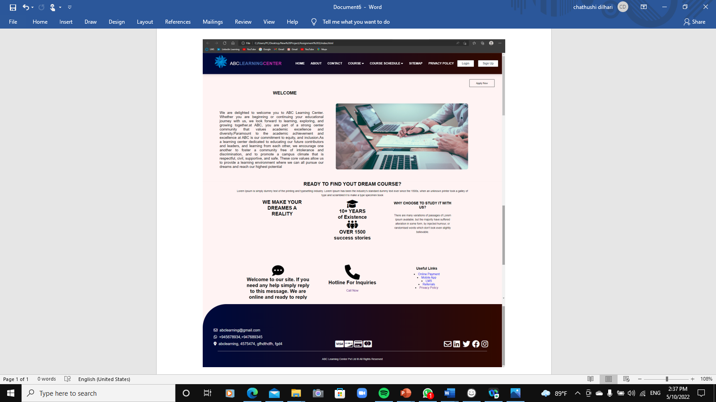

Figure 8:Screenshot of Home Page

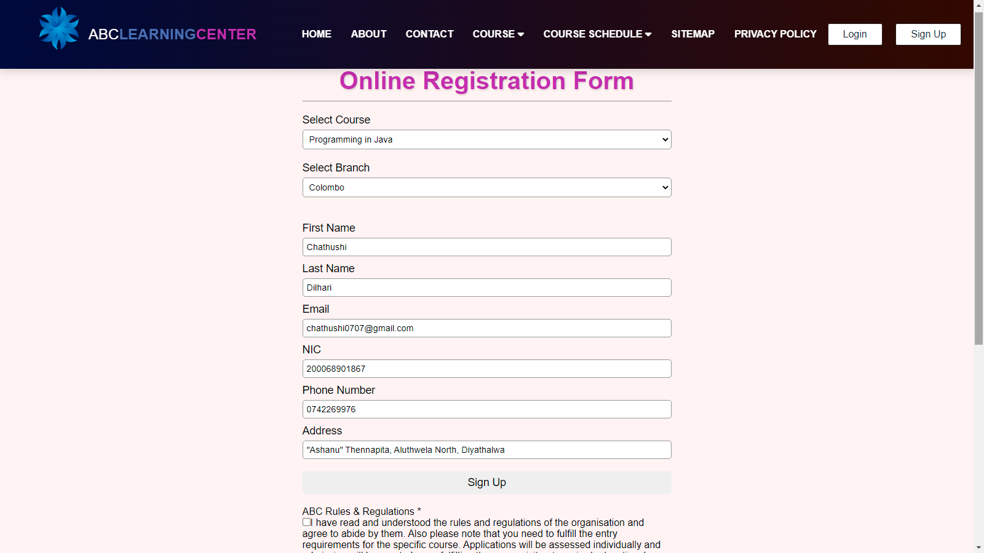Step 2 – Then Visitor will go to the Lead Generation page

Figure 9: Screenshot of Lead Generation Form

Step 3- Fill Up the Form

* Select Course
* Select Branch
* First Name
* Last Name
* Email
* NIC
* Phone Number
* Address
* 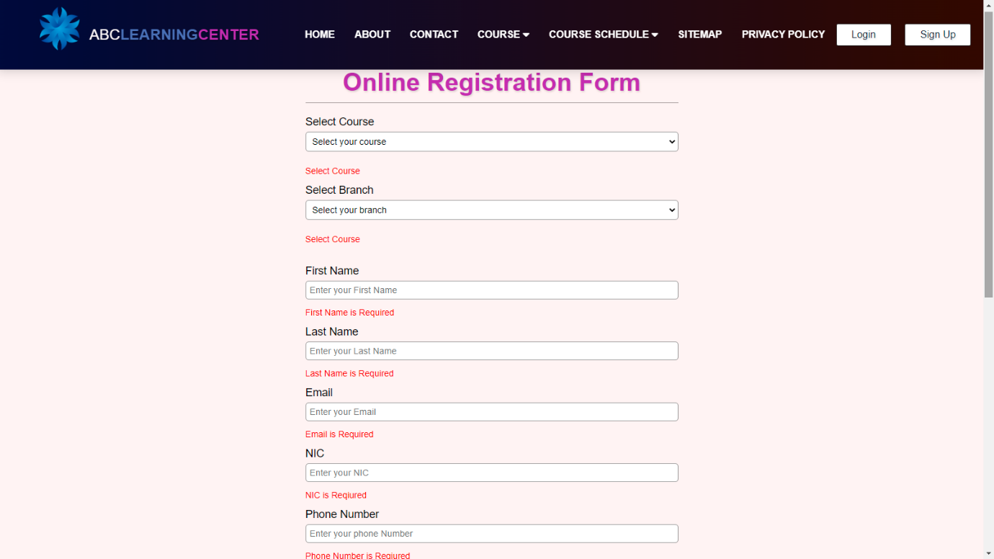Visitor cannot Sign Up without fill whole form because of the validation

Figure 10:Screenshot of Lead Generation Validation

Step 4 – After filled the form visitor can sign up and after that visitor will come thank you page

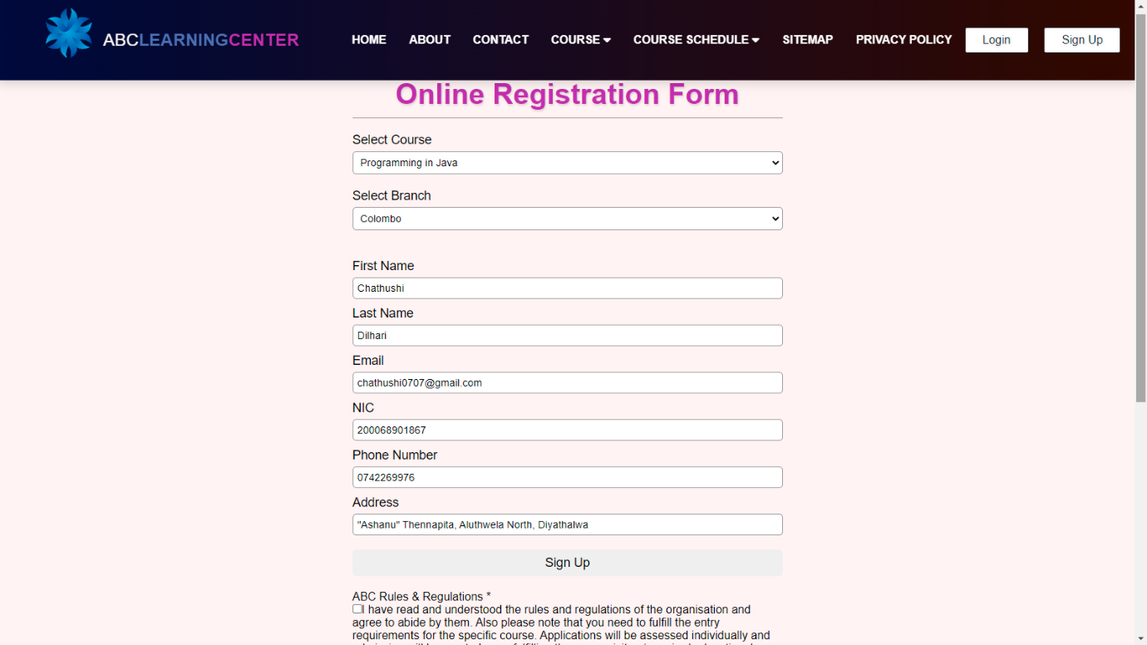

Figure 11: Screenshot of full filled Lead Generation Form

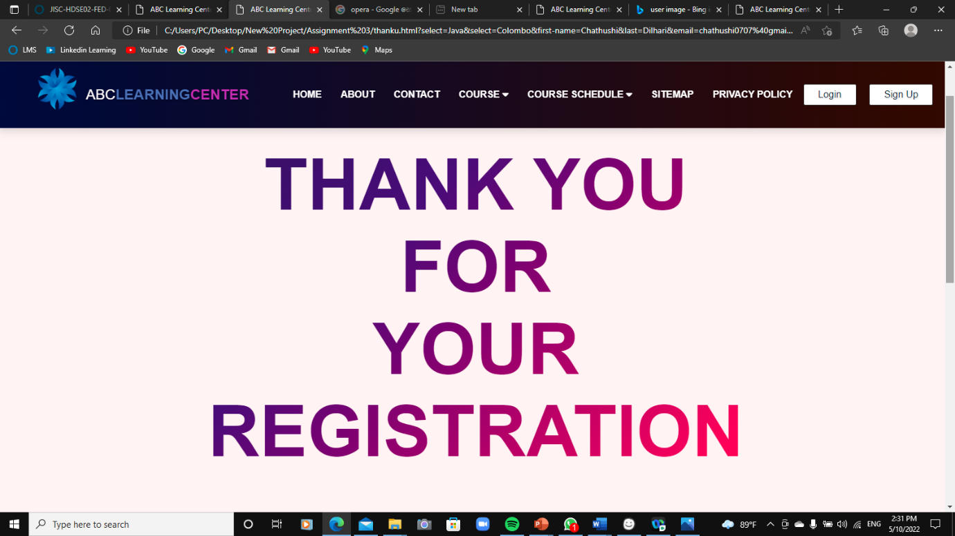

Figure 12: Screenshot of Thank You page

1. USER GUIDE FOR LEAD ADMINISTRATIVE SYSTEM

**Step 1** – After successful registration lead’s information saved in Local Storage

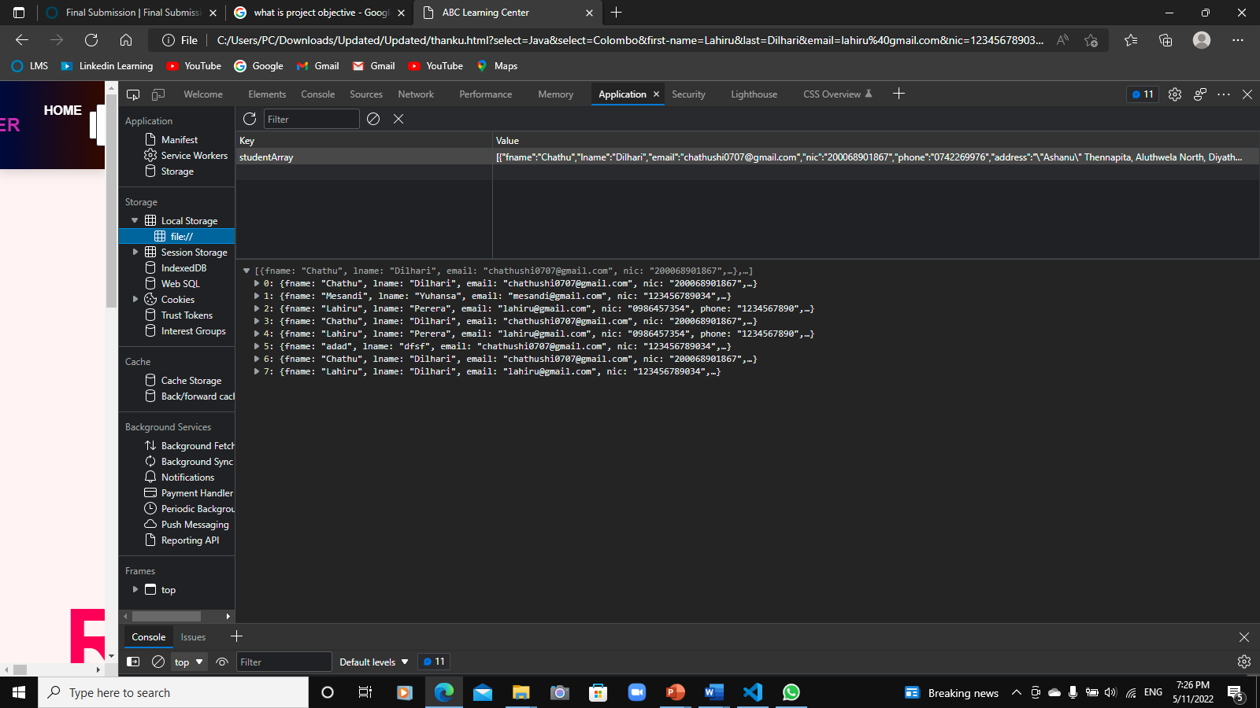

Figure 13:Screenshot of Local Storage

**Step 2** – Lead’s details stored in Lead Administration page

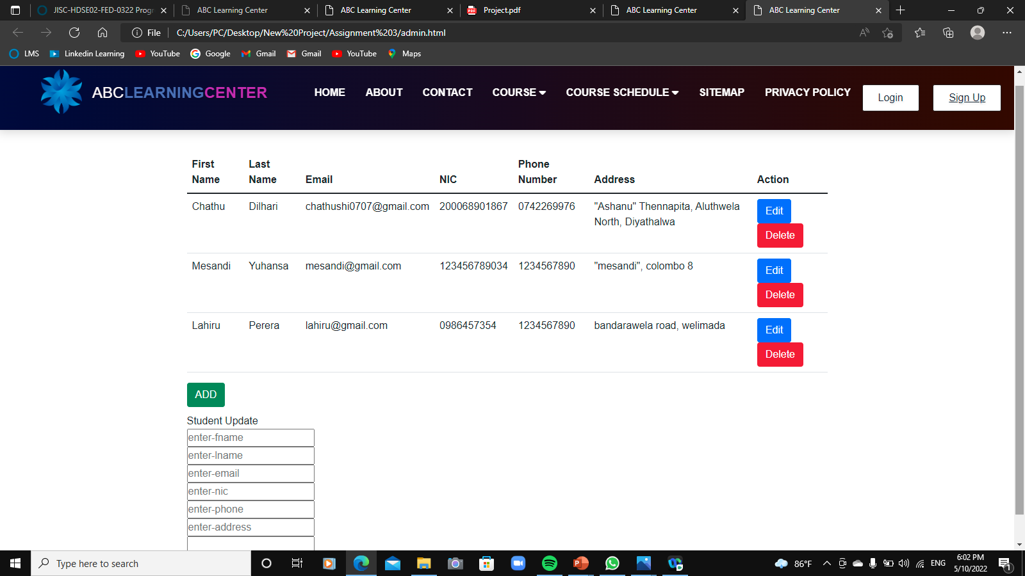

Figure 14: Screenshot of Lead Administration page

Step 3 – Admin can Edit or delete leads

Figure 15: EDIT, DELETE Button in Lead Administration

When admin click the edit button the leads details appears in a new form.



Figure 16: Leads ADD EDIT Form in Lead Administration Form

**Step 3** – Using this (Figure 15) form admin can add new leads, Edit and replace leads.